Ideation Phase
Define the Problem Statements
Date | 2 February 2026
Team ID | LTVIP2026TMIDS28441
Project Name | Civil Engineering Insight Studio
Maximum Marks | 2 Marks

Customer Problem Statement:
Create a problem statement to understand your customer's point of view. The Customer Problem Statement template helps you focus on what matters to create experiences people will love.
A well-articulated customer problem statement allows you and your team to find the ideal A well-articulated customer problem statement helps in understanding the challenges faced by civil engineers and construction professionals. It enables the team to empathize with users and design an AI-powered solution that simplifies structural analysis and documentation.

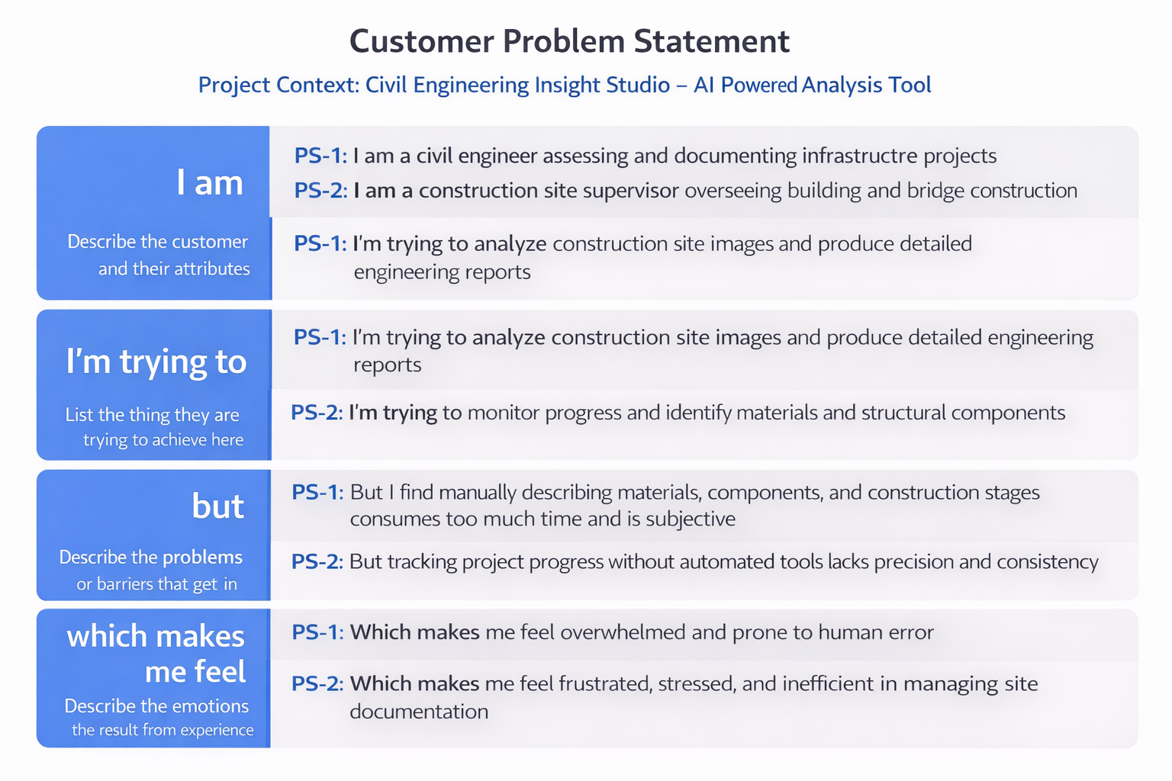

Example:


Problem  Statement (PS) | I am  (Customer) | I’m trying to | But | Because | Which makes me feel
PS-1 | A civil engineer responsible for structural inspection and reporting | Analyze construction site images and generate detailed engineering documentation | Manually identifying materials, structural components, and construction stages from images takes too much time and effort | Accurate structural documentation requires technical expertise, careful observation, and structured reporting | Overwhelmed, time-pressured, and concerned about missing critical structural details
PS-2 | A construction site supervisor managing multiple infrastructure projects | Monitor project progress and document materials and structural elements using site images | There is no automated tool that provides consistent and structured analysis directly from construction images | Traditional reporting methods rely heavily on manual interpretation and subjective judgment | Frustrated, inefficient, and stressed about maintaining accurate and timely project documentation

